Weldon Public Library District
Calendar of Events Summer Reading 2021
“READING COLORS YOUR WORLD!”
Wednesday  June 9th  10:30-12:00  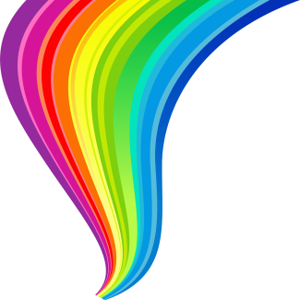  Clay Lady Colors Your World | Wednesday  June 16th  10:30-12:00  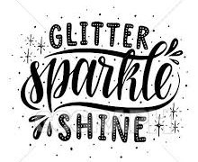  Sparkle  Day | Wednesday  June 23rd  10:30-12:00  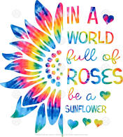  Tie Dye  Day | Wednesday  June 30th  10:30-12:00  Red, White & Blue  Day | Wednesday  July 7th  10:30-12:00  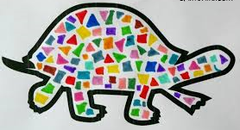  Mosaic  Day | Wednesday  July 14th  10:30-12:00  Silver & Gold  Day

Registration begins May 28th
All children are invited to participate.
Reading will begin May 28th
Weekly Programs begin June 9th 10:30 a.m. – 12:00 p.m.
All Readers will read at their own pace!
Kids/Parents will keep track of the pages read on the Reading log.
All kids will receive prizes, snacks and enjoy a morning of Fun & Activities!
Any questions call 736-2215

