Weldon Public Library District
"Feed Your Brain, READ!"
Calendar of Events Summer Reading 2023
Wednesday  June 7th  10:30-11:30  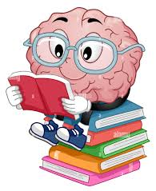  Robot Fun | Wednesday  June 14th  10:30-11:30  Clay Lady | Wednesday  June 21nd  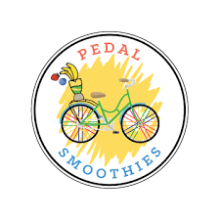  10:30-11:30  "Wheely" Healthy foods | Wednesday  June 28th  10:30-11:30  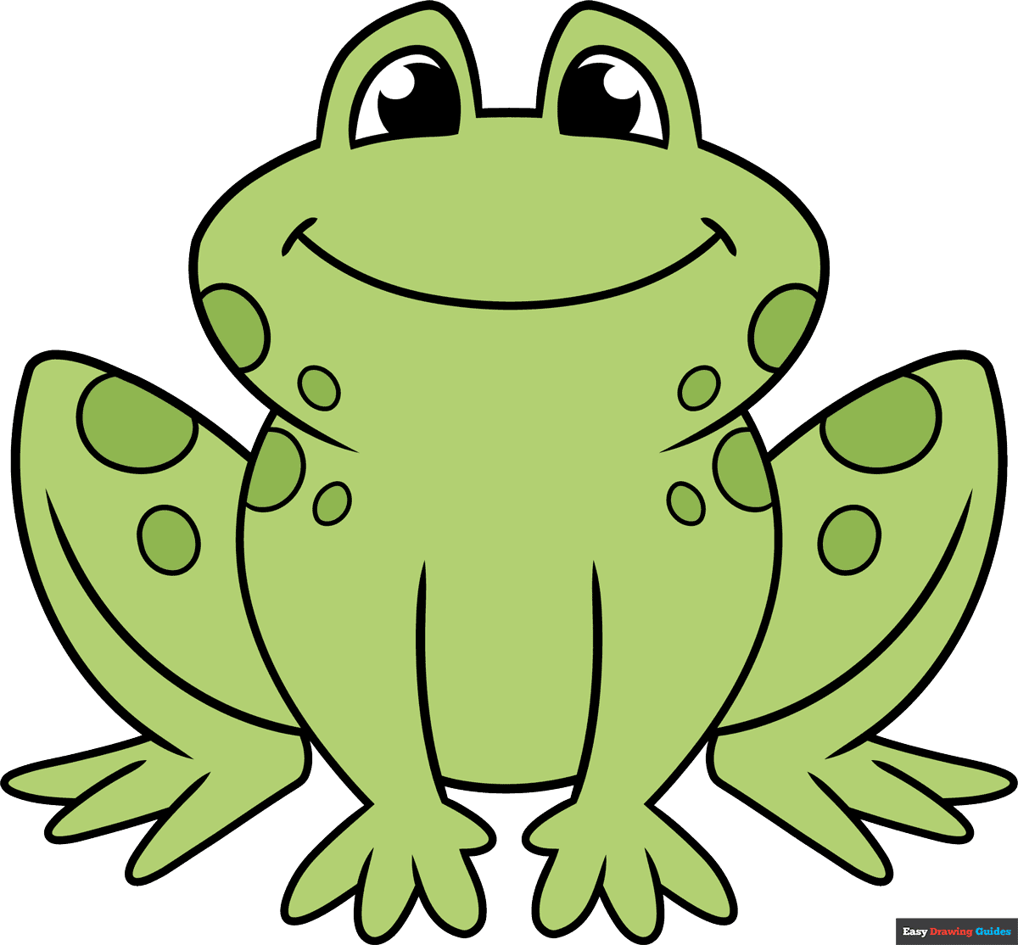  Frog Fun | Wednesday  July 5th  10:30-11:30  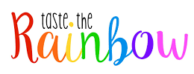  Taste the Rainbow | Wednesday  July 12th  6:00 pm  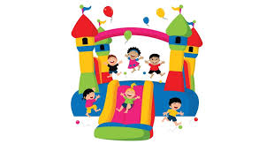  Awards  Party!
Registration & Reading begins May 26th
All children Pre-K - 5th grade are invited to participate.
Weekly Programs begin June 7th 10:30 a.m. – 11:30 a.m.

All Readers will read at their own pace!
Kids/Parents will keep track of the pages read on the Reading log.
All kids will receive prizes, snacks and enjoy a morning of Fun & Activities!
Any questions call 736-2215

